**Assignment 2**

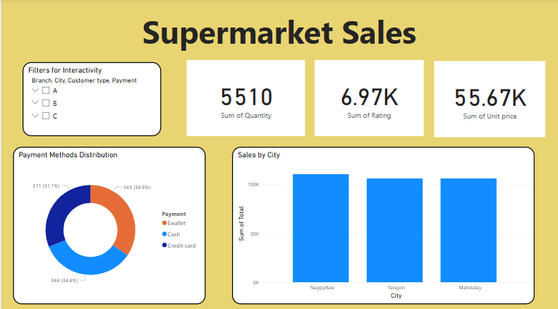

**Key Findings from the Dashboard**

1. **Sales Distribution Across Cities**
   * Sales are nearly **equal in Naypyitaw, Yangon, and Mandalay**, each generating around ₹106K - ₹110K. This indicates a balanced performance across different locations.
2. **Customer Purchase Behavior**
   * The **total quantity sold is 5,510**, showing a significant volume of sales.
   * The **average rating is 6.97K**, reflecting customer satisfaction and engagement.
   * The **total unit price sum is 55.67K**, providing insight into pricing trends.